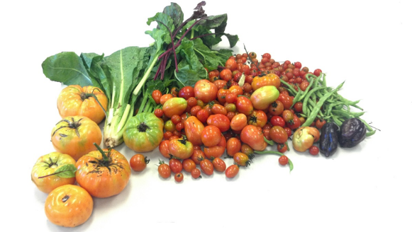
Colorful Cooking Made Easy

Volunteer Cooking Demonstrator Job Description
Share your love of cooking and healthy eating with others by becoming a “Colorful Cooking Made Easy” volunteer cooking demonstrator!
Issue: One of the barriers to eating well is lack of knowledge, skill or experience in the kitchen. Demonstrating how to prepare simple recipes using fresh items from the food pantry can instill confidence in food pantry clients to use healthy foods at home. Learning to cook nutritious meals with limited resources, funds and equipment is valuable for lifestyle change. Providing cooking demonstrations in food pantries is a quick and easy way to highlight basic cooking skills or techniques.
Purpose: Support nutrition education efforts at local food pantries by providing live cooking demonstrations and samples for food pantry clients employing pantry staples and featuring fresh items available in the pantry that week.
Duties & Responsibilities:
- Understand the goals of nutrition education in the food pantry setting.
- Understand and employ food safety guidelines and possess or obtain a current food handler’s card
- Ensure all program materials are kept clean and in working condition
- Establish communication expectations with your food pantry contact
- Empower food pantry clients to cook healthy food options for themselves by engaging in cooking demonstrations and food sampling
- Assist with program evaluation as needed
Skills & Abilities:
- Enjoy cooking fresh, healthy food
- Enjoy working with people and helping others improve their health and wellness
- Be creative and be comfortable using a wide array of food items that may change from week to week at the food pantry
- Be organized and dependable
- Be flexible and be able to adapt to new environments and situation quickly
- Be friendly and treat all food pantry clients with dignity and respect

